What are the various kinds of alerts provided by Web Applications?
As we discussed, there are various types of alerts that the developers can implement on web applications. Each of these alerts/popups needs different kinds of actions to handle these alerts. Let's see what these different types of alerts that the web applications provide are:
- Simple alert: These alerts are just informational alerts and have an OK button on them. Users can click on the OK button after reading the message displayed on the alert box. A simple alert box looks like below:
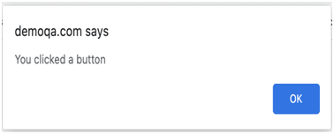
- Prompt Alert: In Prompt alerts, some input requirement is there from the user in the form of text needs to enter in the alert box. A prompt alert box is displayed like below, where the user can enter his/her username and press the OK button or Cancel the alert box without entering any details .

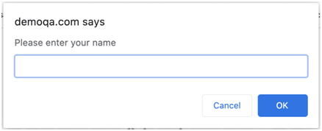

- Confirmation Alert: These alerts get some confirmation from the user in the form of accepting or dismissing the message box. They are different from prompt alerts in a way that the user cannot enter anything as there is no text-box available. Users can only read the message and provide the inputs by pressing the OK/Cancel button.

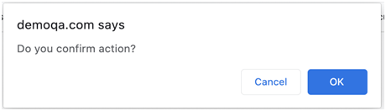

To handle JavaScript alerts, Selenium Web Driver provides the package org.openqa.selenium.Alert and exposes the following methods:
• Void accept(): This method clicks on the 'OK' button of the alert box.
driver.switchTo( ).alert( ).accept();
• Void dismiss(): We use this method when the 'Cancel' button clicks in the alert box.
driver.switchTo( ).alert( ).dismiss();
• String getText(): This method captures the message from the alert box.
driver.switchTo().alert().getText();
• Void sendKeys(String stringToSend): This method sends data to the alert box.
driver.switchTo().alert().sendKeys("Text");

